1-3kVA Online UPS
User Manual

Important Safety Instructions
Definition of symbol in this user manual
 | Indicates a high-level hazard that, if not avoided, will result in death or serious injury.
 | Indicates a potential hazard that, if not avoided, could result in death or serious injury.
 | Indicates a potential hazard that, if not avoided, could result in damage of equipment or environment.
NOTE | Highlights key information, skills and method.  It’s not safety warning, independent of security, environment and equipment.


The battery can present a risk of electrical shock and high short circuit current.
Following precautions should be observed before replacing the battery.
- Wear rubber gloves and boots.
- Remove rings, watches and other metal objects.
- Use tools with insulated handles.
- Do not lay tools or other metal objects on the batteries.
- If the battery is damaged in any way or shows signs of leakage, contact your local representative immediately.
- Do not dispose of batteries in a fire. The batteries may explode.
- Handle, transport and recycle batteries in accordance with local representative

Improper use can result in electrical shock or fire. To ensure safety, observe the following precautions:
- Turn off and unplug the UPS before cleaning it.
- Clean the UPS with a dry cloth. Do not use liquid or aerosol cleaners.
- Never block or insert any objects into the ventilation holes or other openings of the UPS.
- Do not place the UPS power cord where it might be damaged.

Risk of voltage backfeed
Before operating this circuit, isolate the UPS and check for hazardous voltages between the ports as well as between the ports and ground.

- The UPS must be installed and commissioned by the manufacturer or its authorized certified agent. Otherwise, it may pose a risk to personal safety and cause UPS failure. Any resulting damage to the UPS will not be covered under warranty.
- The UPS is designed for commercial and industrial purposes only and must not be used as a power source for any life-support equipment.
- This product is a Class C2 UPS. When used in residential areas, installation restrictions or additional measures may be required to suppress radio frequency interference.

This equipment complies with 2014/35/EU (LVD), 2014/30/EU (EMC), and 2011/65/EU (RoHS), as well as the following UPS product standards:
IEC/EN 62040-1: General safety requirements for UPS
IEC/EN 62040-2: Class C2 UPS
IEC/EN 62040-3: Performance requirements and test methods
The installation of the device must comply with the above requirements and use accessories specified by the manufacturer.

Service area
All internal maintenance and servicing of the equipment must be performed by trained personnel using appropriate tools. Components located behind protective covers that require tools for removal are not user-serviceable.
This UPS fully complies with the safety requirements for equipment in its operational environment. The UPS and battery modules contain hazardous voltages, which are inaccessible to non-maintenance personnel. The risk of exposure to high voltage is minimized, as hazardous voltage components are only accessible after removing protective covers using tools. If general guidelines are followed and the procedures recommended in this manual are adhered to, there will be no risk of danger.

large leakage current
Before connecting to the input power source (including AC mains and batteries), ensure that reliable grounding is established.
The earth leakage current shall not exceed 3.5 mA.
When selecting a residual current operated circuit-breaker (RCCB) or any other residual current device (RCD), consider the possible transient and steady-state earth leakage currents during equipment startup.
Note that the earth leakage current of the connected loads will also flow through the RCCB or RCD.
The grounding of the equipment must comply with local electrical regulations.
Output short circuit current
Model | Maximum Peak current for AC mode | Maximum RMS for AC mode
1kVA | 22.4A | 8.3A
2kVA | 38.3A | 20.4A
3kVA | 63.9A | 32A

Tables of contents
Important Safety Instructions 2
1.Electromagnetic Compatibility 7
2. Introduction 8
2.1 Front View 8
2.2 Rear View 8
3. System Description 12
3.1 Rectifier/Power Factor Correction (PFC) Circuit 12
3.2 Inverter 12
3.3 DC-to-DC Converter 12
3.4 Battery 13
3.5 Dynamic Bypass 13
3.6 UPS Operating Modes 13
4. Product Specification and performance 16
5. Installation 18
5.1 Unpacking and Inspection 18
5.2 Mechanical Installation 19
5.2.3.2 Branch circuit breaker 22
5.3 Operating procedure for connecting the long backup time model UPS with the external battery 23
5.4 communication connections 24
6. Display and Settings 27
6.1 Description of Panel 27
6.2 Description of LCD Menu 28
6.3 Parameters Setting 30
7. Operation 33
7.1 Turn on the UPS at normal mode 33
7.2 Turn on the UPS from battery 33
7.3 Turn off the UPS at normal mode 33
7.4 Turn off the UPS at battery mode 33
8. Battery Maintenance 34
8.1 Battery maintenance 34
8.2 Replacing Internal Battery Pack 34
9. Battery disposal and replacement procedures 37
9.1 Battery Disposal 37
9.2 Battery Replacement Procedures 37
10. Trouble shooting 38
10.1 Checking UPS status 38
10.2 Solution 38
Annex A. Dry Contact Card 42
Annex B. Battery Pack Assembly (rack tower model) 44

1.Electromagnetic Compatibility
* Safety
IEC/EN 62040-1-1
* EMI
Conducted Emission.........IEC/EN 62040-2 | Class C2
Radiated Emission............IEC/EN 62040-2 | Class C2
*EMS
ESD..................................IEC/EN 61000-4-2 | Level 4
RS....................................IEC/EN 61000-4-3 | Level 3
EFT..................................IEC/EN 61000-4-4 | Level 4
SURGE............................IEC/EN 61000-4-5 | Level 4
Low Frequency Signals..............:IEC/EN 61000-2-2
Warning: This is a product for commercial and industrial application in the second environment-installation restrictions or additional measures may be needed to prevent disturbances.


- This is a product for restricted sales distribution to informed partners.
- Installation restrictions or additional measures may be needed to prevent radio interference.
- Operated the UPS in an indoor enviroment only in an ambient temperature range of 0-40°C(32-104°F).
- Install it in a clean environment, free from moisture, flammable liquids, gases and corrosive substance.

This UPS contains no user-serviceable parts except the internal battery pack. Under no circumstance attempt to gain access internally, due to the risk of electric shock or burn.
Servicing of batteries should be performed or supervised by personnel knowledgeable of batteries and the precautions.
Keep unauthorized personnel away from the batteries.
Proper disposal of batteries is required. Refer to your local laws and regulations for disposal requirement.
DO NOT CONNECT equipment that could overload the UPS or demand DC current from the UPS, for example: electric drills, vacuum cleaners, laser printers, hair dryer or any appliance using half-wave rectification.

2. Introduction
The UPS is an on-line UPS. An on-line UPS continuously regulates its output voltage, whether utility power is present or not. It supplies connected equipment with clean sinewave power.
For ease of use, the UPS features a LCD display to indicate all information of UPS, and provide kinds of function buttons.

2.1 Front View
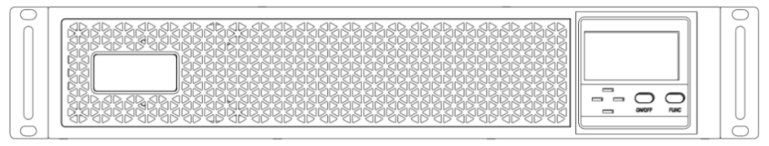
Rack tower model 1-3K
1kVA and long backup model 2K,3K standard model 2KB,3KB

2.2 Rear View
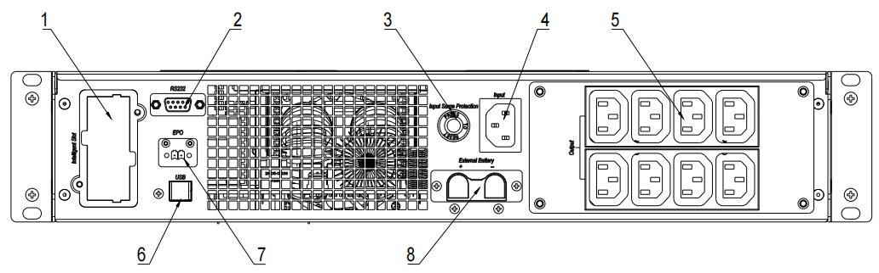
1kVA rack tower
1 | Intelligent slot.
2 | RS-232 communication port. DB9 type.
3 | Input surge protection slot.
4 | 1K: Input socket 10A.
5 | Output Socket IEC C13
6 | USB port. B type. (Optional).
7 | EPO. Short to activate.
8 | External battery port. Optional for standard model.
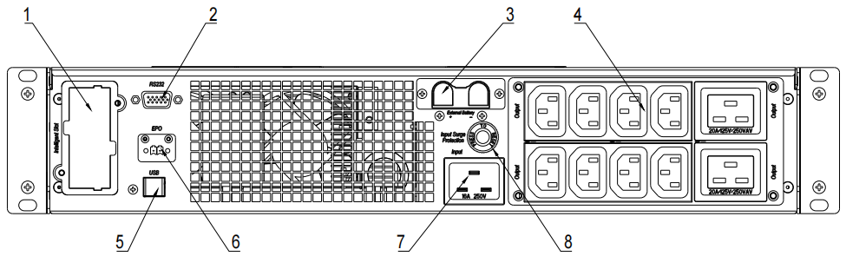
2kVA, 3kVA rack tower
1 | Intelligent slot.
2 | RS-232 communication port. DB9 type.
3 | External battery port. Optional for standard model.
4 | Output Socket IEC C13+C19. Only 8*C13 for 2kVA.
5 | USB port. B type. (Optional)
6 | EPO. Open to activate.
7 | 2K/3K: Input socket 16A.
8 | Input surge protection slot.

1K tower
2K,3K long backup tower

2K,3K standard tower
1 | Input socket
2 | Input surge protection
3 | Output socket
4 | Intelligent slot
5 | USB (optional)
6 | RS232
7 | External battery terminal
8 | EPO (NC)
9 | Output 16A connector. Not default for 2kVA.

The sockets on the rear panel could be different in different area and application according to user requirements, such as British, AUS, India, NEMA and so on.

3. System Description
Fig 3- 1:UPS working diagram

3.1 Rectifier/Power Factor Correction (PFC) Circuit
In normal operation, the rectifier/power factor correction (PFC) circuit converts utility AC power to regulated DC power for use by the inverter while ensuring that the waveform of the input current used by the UPS is near ideal. Extracting this sinewave input current achieves two objects:
- The utility power is used as efficiency as possible by the UPS.
- The amount of distortion reflected on the utility is reduced.
This results in cleaner power being available to other devices in the building not being protected by the UPS.

3.2 Inverter
In normal operation, the inverter (INV) utilize the DC output of the power factor correction circuit and inverters it into precise, regulated sinewave AC power. Upon a utility power failure, the inverter receives its required energy from the battery through the DC-to-DC converter. In both modes of operation, the UPS inverter is on-line and continuously generating clean, precise, regulated AC output power.

3.3 DC-to-DC Converter
The DC/DC converter (LLC and PFC) utilizes energy from the battery system and raises the DC voltage to the optimum operating voltage for the inverter. The converter includes boost circuit which is also used as PFC.
The DC/DC converter (CHG) also converts DC bus energy to charge batteries in all models except 1kVA standard model.

3.4 Battery
The standard model include value-regulated, non-spillable, lead acid batteries inside. To maintain battery design life, operate the UPS in an ambient temperature of 14-25°C.

3.5 Dynamic Bypass
Bypass connect loads directly to the utility if inverter was failure.

The bypass power path does NOT protect the connected equipment from disturbances in the utility supply.

3.6 UPS Operating Modes

3.6.1 Normal Mode
When utility power is normal, the UPS will operate in Normal mode (double conversion) that employs the rectifier and inverter to provide stabilized voltage and frequency power to the connected equipment. The battery charger will recharge or maintain the battery at full capacity. Figure 3-2 below shows the diagram of Normal mode.
Fig 3- 2:normal mode

3.6.2 Bypass Mode
Bypass mode supplies power to the load from the input source directly, if an overload or fault occurs during normal operation. If mains power fails or the mains voltage goes outside of the permissible range during bypass mode operation, the UPS will shutdown and no output is supplied to the connected equipment.
Fig 3- 3:bypass mode
3.6.3 Battery Mode
Battery mode supplies battery power to the load if utility power fails or if the utility voltage goes outside of the permissible range. The LCD screen displays battery icon and the buzzer beeps once each second, see Figure 2.12 below shows the diagram of Battery mode.
NOTE: The batteries are fully charged before shipment. However, transportation and storage inevitably cause some loss of capacity. To ensure adequate back up time, it is recommended to charge the batteries for at least 3 hours before connecting equipment.

Fig 3- 4:battery mode

3.6.4 ECO mode
The energy saving ECO mode reduces power consumption by powering the connected equipment via bypass while the bypass voltage and frequency are stable and within the user defined operational settings. ECO mode keeps the rectifier/PFC and inverter operating to maintain synchronization to the bypass. This allows seamless transfers to inverter power when the input mains power falls outside of those thresholds.
NOTE: It’s recommended using ECO mode to power equipment that is not sensitive to power grid quality to reduce mains power consumption.

Fig 3- 5:ECO mode

4. Product Specification and performance
1. General Specification
Model |  | 1kVA Standard rack &  tower | 1kVA Long backup rack & tower | 1.5kVA Long backup rack | 1.5kVA Long backup tower | 2kVA Standard rack & tower | 2kVA Long backup rack & tower | 3kVA Standard rack & tower | 3kVA Long backup rack & tower
Power Rating VA/W |  | 1000VA/1000W |  | 1500VA/1500W |  | 2000VA/2000W |  | 3000VA/3000W
Frequency (Hz) |  | 50/60
Input | Voltage | 110Vac~300Vac (176~264Vac at full load)
 | Current | 10A max/5.5A max. |  | 16A max/8A max |  | 20A max/11A max |  | 30A max/16A max
Battery | Model | 9/7AH | / | 9AH |  | 7/9AH | / | 9/7AH | /
 | Numbers | 2/3 |  | 3 |  | 4/6 |  | 6/8
 | Max charging | 1A | 1-12A | 1A | 1-12A | 1A | 1-12A | 1A | 1-12A
 | Voltage | 24VDC/36VDC |  | 36VDC |  | 48VDC/  72VDC |  | 72VDC/96VDC
 | Current | 55A max (2,3,4,6 blocks for 1K/1.5K/2K/3K)  35A max (3,6,8 blocks for 1K/2K,3K)
Output | Voltage | 200V/208V/220V/230V/240V
 | Current | 5/4.8/4.5/4.3/4.2A |  | 7.5/7.2/ |  | 10/9.6/9/8.6/8.4A |  | 15/14.4/13.5/12.9/12.6A
Protection |  | IP20, pollution degree 2
Noise (1m) |  | 45dB |  | 47dB |  | 50dB
Icw |  | 1kA
Dimension (WxDxH) mm |  | 440*450*86（Long backup time rack/ standard backup time rack）  144*355*226（Long backup time tower/ standard backup time tower） |  |  |  | 440*450*86（Long backup time rack）  440*590*86（standard backup time rack）  144*398*223 (Long backup time tower)  190*400*328 (standard backup time tower)
2. Electrical Performance
Input
Model | Voltage | Frequency | Power Factor
1-3kVA | Single-phase | +-5Hz@50or60Hz | >0.99(Full load)
3. Operating Environment
Temperature | Humidity | Altitude | Storage temperature
0°C-40°C | <95% | <1000m | -20°C-70°C
Output
Voltage Regulation | Power  Factor | Frequency tolerance. | Distortion | Overload capacity | Crest ratio
±1% | 1 | ±0.5% of normal | THD<2%@Full Linear Load  THD<5%@Full nonlinear load | 102%~110%: 30mins，110%~125%:10mins，125%~150%: 30 seconds | 3:1 maximum
NOTICE：If the UPS is installed or used in a place where the altitude is above than 1000m, the output power must be derated in use, please refer to the following:
Altitude (M) | 1000 | 1500 | 2000 | 2500 | 3000 | 3500 | 4000 | 4500 | 5000
Derating Power | 100% | 95% | 91% | 86% | 82% | 78% | 74% | 70% | 67%

Installation

Risk of electric shock. Can cause equipment damage, injury and death.
Before beginning installation, verify that all external overcurrent protection devices are open (off), and that they are locked out and tagged appropriately to prevent activation during the installation, verify with a voltmeter that power is off and wear appropriate, approved personal protective equipment per NFPA 70E. failure to comply can cause serious injury or death. Before proceeding with installation, read all instructions. Follow all local codes.

DO NOT start the UPS until after the installation is finished, the system is commissioned by an authorized engineer, and the external input circuit breakers are closed.

5.1 Unpacking and Inspection

5.1.1 Unpacking
Before unpacking the unit, check if the package is damaged during transportation. Do not turn on the unit if there is any damage of package.
Unpack the package with tool such as knife.
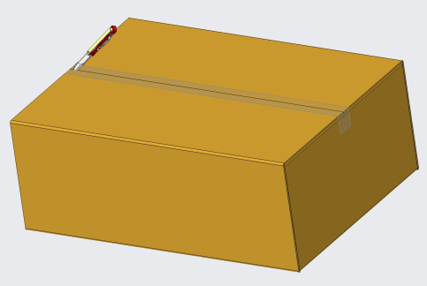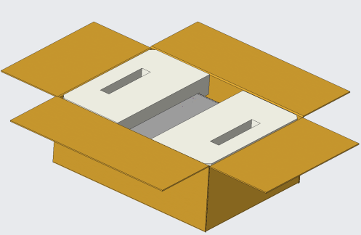

5.1.2 Inspection
1) Check the package contents. The shipping package contains:
1 UPS
1 User manual
1 Input Cable
1 USB cable (option)
1 Battery Cable (For Long backup model only)
2) Inspect the appearance of the UPS to check if there is any damage during transportation. Do not turn on the unit and notify the carrier and dealer immediately if there is any damage or lacking of some parts.

5.2 Mechanical Installation
For rack-tower models, two installation modes are available: tower installation and rack installation, depending on available space and use considerations. For tower models, only tower installation is available.
NOTE
  - The UPS must be installed in a location with good ventilation, far away from water, inflammable gas and corrosive agents.
  - Ensure the air vents on the front and rear of the UPS are not blocked so as to ensure good ventilation, at least 300mm.
  - Condensation to water drops may occur if the UPS is unpacked in a very low temperature environment. In this case it is necessary to wait until the UPS is fully dried inside out before proceeding installation and use. Otherwise there are hazards of electric shock.

5.2.1 Tower Installation (rack tower model)
Various installation configurations are available: single UPS, single UPS with single or multiple battery cabinets. Their installation methods are all the same.
The installation procedures are as follows:
Step 1: Take out the support bases from the accessories. Their appearances are shown in Fig.4-1.
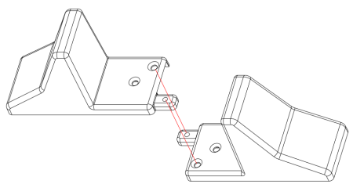
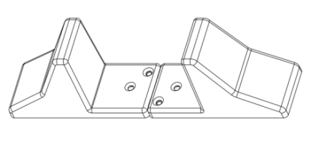
Fig.4-1 Support bases
Step 2: Adjust the direction of UPS operation and display panel.
1. Remove the front plastic bezel cover gently and remover two brackets screws, as shown in Fig.4-2.
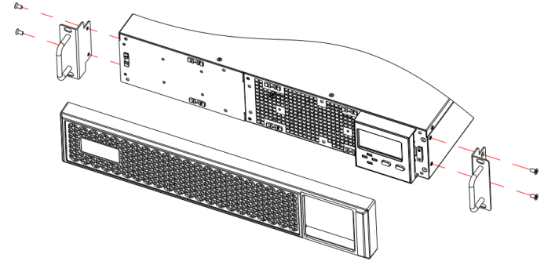
Fig.4-2 Removing the front plastic bezel cover
2.Pull the operation and display panel gently, rotate it 90 degrees clockwise and snap it back into position, as shown in Fig.4-3
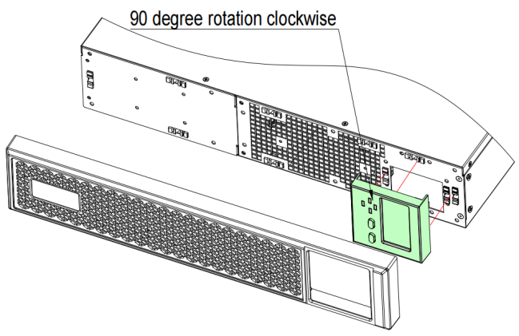
Fig.4-3 Rotating the operation and display panel
3. Restore the front plastic bezel cover to the UPS. At this point, the UPS operation and display panel have been rotated 90 degrees clockwise, which provides upright viewing for users.
Step 3: Place the UPS (and battery cabinet) on the support bases. Each UPS needs two pairs of support bases to install, as shown in Fig.4-4.
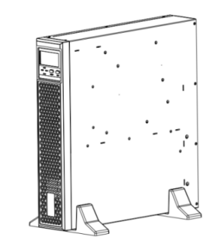
Fig.4-4 Tower installation

5.2.2 Rack Installation
Various installation configurations are available: single UPS, single UPS with single or multiple-battery. The installation methods are all the same.
Installation steps:
Place the UPS onto the guide rail in the rack, and push it completely into the rack along the guide rail (it is prohibited to move the UPS through the brackets). And fix the UPS onto the rack.
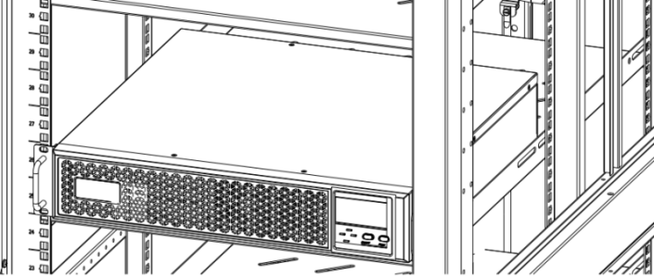
Fig.4-5 Installing UPS

5.2.3 Power connection
5.2.3.1 Setup the UPS
1. Input cable connection
The UPS is connected via the power plug, please use a proper socket with protection against electric current, and pay attention to the capacity of the socket: over 10A for 1kVA, over 16A for 2kVA and 3kVA.
2. Output cable connection
The total output power shall not exceed 1kVA/1kW,2kVA/2kW,3kVA/3kW. Simply plug the load power cable to the output socket of UPS to complete connection.
*Except from using socket as output, 3kVA has output terminal (optional) as well for load which current is over 10A.
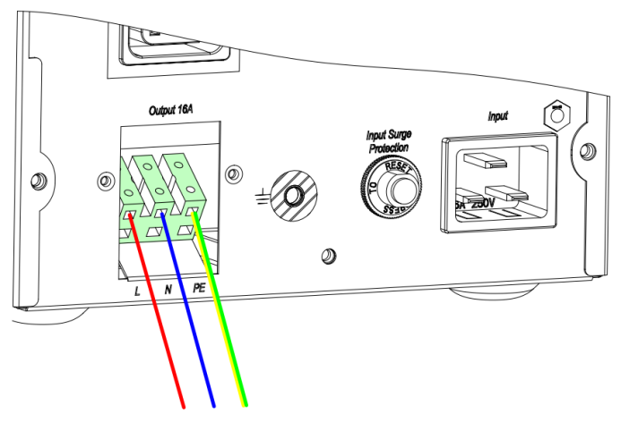
Fig.4-6 Output terminal of 3kVA
1). Remove the cover of output terminal.
2). Use AWG14 wires for terminal wiring configuration as fig.4-6.
3). Please check if the wires are securely affixed.

5.2.3.2 Branch circuit breaker
The installer must provide an upstream branch circuit breaker, see Table below, for the ratings.Observe the following guidelines and specifications when making the hard wire input and output connections:
- Provide circuit breaker protection according to local codes. The mains disconnect should be within sight of the UPS or have an appropriate lock out.
- It is recommended to use a Class D circuit breaker.
- Maintain service space around the UPS or use flexible conduit.
- Provide the output distributions panels, circuit breaker protection, or emergency disconnects according to local codes.
- Do not install the input and output wiring in the same conduit.
Rating (VA) | Recommended breaker rating (A)
1000 | 10
1500 | 13
2000 | 16
3000 | 20

5.3 Operating procedure for connecting the long backup time model UPS with the external battery
Notice: if need to connect external battery pack with BMS, it need extra RS485 port for UPS to communicate with BMS. Set communication as 485 and protocol as 3cc-BMS (B on LCD), set Baud rate as 9600.
1. The nominal DC voltage of external battery pack is 36VDC/1kVA, 72VDC/2kVA, 72VDC/3kVA. Connect the batteries of the pack in series to ensure proper battery voltage. To achieve longer backup time, it is possible to connect multi-battery packs, but the principle of “same voltage, same type” should be strictly followed.
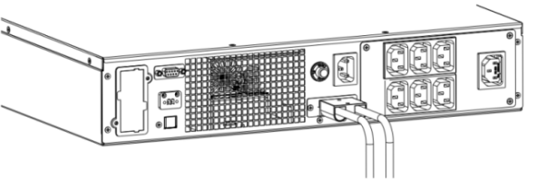
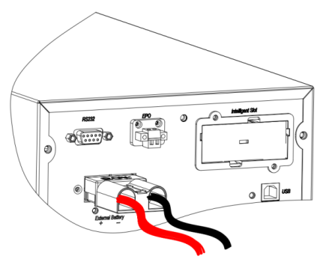
Fig.4-7 Battery terminal connection
- Take out battery cables and connect the RED wire to the “+” terminal of the battery pack. Connect the BLACK wire to the “-“ terminal of the battery pack.
- Plug the Anderson terminal to UPS as Fig.4-7

DO NOT connect the battery plug to the battery socket of UPS first, otherwise, it may cause electric shock.

5.4 communication connections
UPS offers several communication interfaces and ports.

We recommend that signal cable lengths be less than 3m (10ft), and are kept away from power cabling.
To allow for unattended UPS shutdown and status monitoring, connect the communication cable one end to USB port (HID) and the other to the communication port of your PC. With the monitoring software installed, you can schedule UPS shutdown and monitoring UPS status through PC. To allow for UPS setting and detailed status monitoring, connect the DB9 cable one end to RS232 port, or connect USB cable to USB port (USB only) and the other end to the communication port of PC. With the management software, you can set UPS, monitoring UPS and send operating command to UPS.
UPS offers dry contacts ports as option, please refer to Annex A for the connection of dry contacts.

5.4.1 connecting SNMP card
SNMP card is provided only while it’s required as option. See the appropriate figure for your model in rear panel on chapter 2.2 for the location of the card port.
- Remove the screws from the slot cover plate to remove it
- Insert the card into the slot, and secure with the screws that held the cover plate
To make connections to the card,refer to the user manual of SNMP card.

5.4.2 Connecting a USB cable
The UPS includes a USB type-B connector only while it’s configured as standard. See the appropriate figure for your model in rear panel on chapter 2.2 for the location of the port.
The USB port connects the UPS to a network server or other computer system. The HID type USB port supports HID. To use the HID protocol for simple monitoring, refer to the user manual of HID.
The USB port (not HID type) support management software.

5.4.3 Connecting a DB9 cable
The UPS includes a RS232 connector (DC9 type). See the appropriate figure for your model in rear panel on chapter 2.2 for the location of the port. The RS232 port connects the UPS to a PC for the use of monitoring. To use management software, refer to the user manual of software.

5.4.4 Connecting to the EPO (emergency power off) port
EPO (Emergency Power Off) is a function to shutdown UPS completely at emergency condition. This function can be activated through a remote contact or a similar switch provided by the user. Keep the P1 and P2 closed for UPS normal operation. When emergencies happen , EPO is activated by opening the EPO terminals, UPS shutdown the rectifier ,inverter output immediately．
Fig.4-8 EPO function
5.5 Installing the External Battery Cabinets (EBC)
Optional EBC may be connected in parallel to the UPS to provide additional battery run time.

Risk of electric shock. Can cause equipment damage, injury and death.
Disconnect all local and remote electric power supplies before working with the UPS. Ensure that the unit is shutdown and power has been disconnected before any maintenance.
To install the EBC:
Inspect the EBC for freight damage. Report damage to the carrier and your local dealer or representative.
For tower installation, EBC are placed on one side of the UPS in a tower configuration.
For rack installation, EBC are stacked beneath of the UPS in a rack configuration.
Verify the EBC breaker is in the “off” position.
Connect the supplied EBC cables to the rear of the cabinet, then to the rear of the UPS.
Turn the EBC breaker to the ON position

When removing an EBC, turn off the circuit breaker on the rear of the cabinet before disconnecting the cable.
If shipping or storing the UPS for an extended time, disconnect the EBC to minimize standby current drain on the batteries and help maintain design life
Maximum 4 EBC can be connected to the UPS.
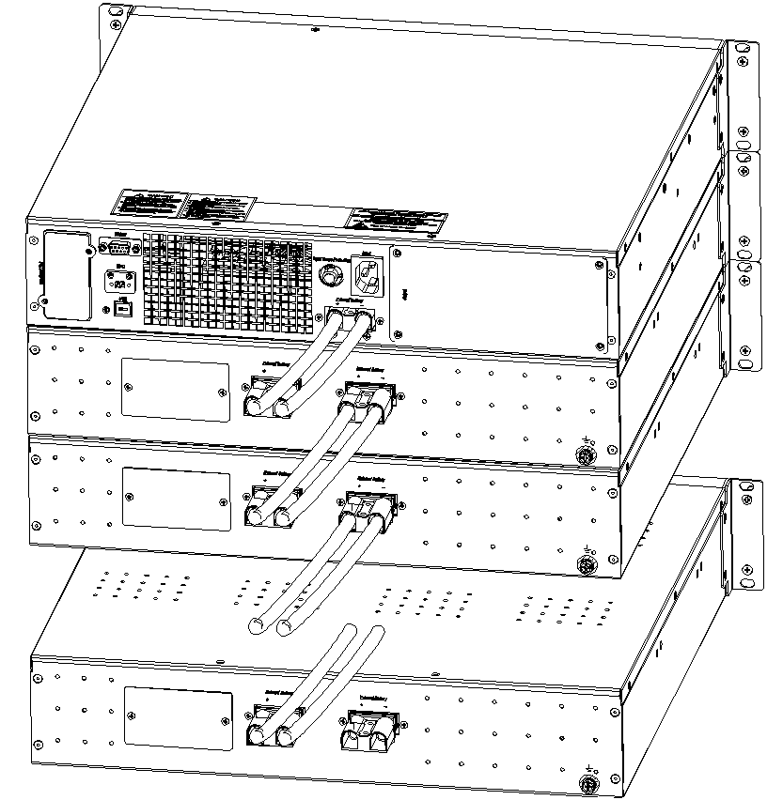
Fig.4- 9 Example of EBC connected to the UPS

Display and Settings
Fig 3- 6: Display Panel

6.1 Description of Panel
Controls | Description
ON/OFF | 1.Press ON/OFF to start inverter when rectifier is OK  NOTE  Not available when UPS is set in automatically start mode  2.Press ON/OFF for 2.5s to shut down inverter and transfer to bypass  3.Press ON/OFF for 2.5s to shut down UPS completely when UPS is in battery mode  4.Press ON/OFF to confirm setting when in setting mode
FUNC | Functional button:  1.Press FUNC to page down to check LCD menu  2.Press FUNC for 1.5s at the page 1 to mute off, press again to mute on  3.Press FUNC and ON/OFF together for 2.5s to enter in setting mode  4.Press FUNC for 1.5s at the page 4 to fault clear
Indicators | Description
REC | Rectifier indicator: green--rectifier is normal, green flicker--rectifier is starting, dark—rectifier is not working
INV | Inverter indicator: green--inverter is normal, green flicker--inverter is starting or tracking with bypass(ECO), dark—inverter is not working
BYP | Bypass indicator: yellow—bypass is normal, yellow flicker—bypass alarm ,dark—UPS is in normal mode and bypass is normal
BAT | Battery indicator: yellow—battery discharged, yellow flicker—No battery or battery alarm, dark—battery is connected

Fig 3- 7: LCD Menu

6.2 Description of LCD Menu
Menu | Information
Input information | Main input: voltage VAC, current A, frequency Hz  Bypass input (bypass “B” flicks):  Voltage VAC, current A, frequency Hz  PFC temperature: 66c—66℃
Battery information | Battery: voltage VDC, Battery current A, remained capacity %, battery low alarm LOW, battery temperature (c)
Output information | Output information:  Voltage, current, frequency  INV temperature: 66c--66℃
Alarm | : mute on/off  OV LOAD : over load  SHORT: output short  ECO: working in ECO mode
Load/Version/model/Code | Load: active load KW, apparent load kVA, load percent %  VER: firmware version. V1.021 for example (v1 and 021 display in turn)  MODE: system model, 1b,1L,2b,2L,3b,3L  : warning code, refer to “7. Trouble Shooting” to get detailed code list
Others | : setting mode  BYPASS: bypass conversion
Press FUNC to check information:
Page | Description
Page 1:
INPUT voltage: 220VAC
OUTPUT voltage: 220VAC
Battery voltage: 40.7VDC
LOAD: 0.5kVA
Load percent (%), active power(KW), apparent power(kVA) are displayed in turn
Press “FUNC” for 2.5s in this page to mute off
Page 2:
INPUT frequency: 50Hz
OUTPUT frequency: 50Hz
Battery AH: 9AH-200AH
System MODEL: 1b—1kVA standard
L- Long backup model, b- standard model
Page 3:
INPUT current: 2.3A
OUTPUT current: 2.3A
Battery current: 1A (downwards arrow: charge, upwards arrow: discharge, no arrow: no battery)
Firmware Version: V1.17 (v1 and 17 display in turn)
Page4:
Input and output temperature29℃,33℃
Battery temperature: 26℃
alarm code: 0
Press “FUNC” for 2.5s to manually fault clear

6.3 Parameters Setting
If want to set rated parameters, press ON/OFF and FUNC buttons together for 2.5s to enter in setting mode, “SETTING” on the bottom of LCD present and all LEDs flicks, LCD displays current setting in turn.
Main page | Press “FUNC” to select setting menu, press “ON/OFF” to confirm selection and enter in setting.  232—RS232 setting,  345—SNMP card setting, 485—485 setting
Input and output rated voltage setting | Set 240 then enter in rated setting. Select input and output voltage as 200VAC/ 208VAC/ 220VAC/ 230VAC/ 240VAC, press FUNC to select, press ON/OFF to confirm selection and enter in next page
Input and output rated frequency setting | Select input and output frequency as 50Hz/60Hz, press FUNC to select, press ON/OFF to confirm selection and enter in next page
Battery capacity setting | Select battery AH according to real application, press FUNC to select, press ON/OFF to confirm selection and enter in next page
Charger current setting | Charger current could be set as below:  Standard model: 1A  Long backup model: 1,2,3,4,5,6,7,8A  Press FUNC to select, press ON/OFF to confirm and enter in next page
System mode | S-Normal mode  E-ECO mode  Press FUNC to select, press ON/OFF to confirm and exit setting.
Exit | If all settings are finished, settings will be displayed on LCD, press FUNC to exit. The setting will be activated after restart UPS.
Communication protocol setting | Select 232, 240 or 485 at main page to set communication:  Baud rate:96—9600, 12—1200, 24—2400,48—4800,192--19200  Press “ON/OFF” to confirm and enter in ID setting
Communication ID setting | Set ID as 1 to 32.  Press “ON/OFF” to confirm and enter in protocol setting
Communication protocol setting | 0cc--ModBus  1cc--RTU  3cc--BMS  Press “ON/OFF” to confirm and finish communication setting
Exit setting | If all settings are finished, settings will be displayed on LCD, press FUNC to exit. The setting will be activated after restart UPS.
NOTE
Press “FUNC” and “ON/OFF” at any setting page for 2.5s to exit setting mode.

7. Operation

7.1 Turn on the UPS at normal mode
1) After you make sure that the power supply connection is correct, and then close the battery breaker (long backup time model), after that turn on the utility power. The fans rotate, and LCD is on
2) REC led starts to green flicker. BYP led is steady yellow and UPS works in bypass model. Inverter then starts and the INV led green flickers when REC led is steady green.
3) About several seconds, the UPS turn into normal mode. Inverter feeds power to the load.

7.2 Turn on the UPS from battery
1) Make sure that the breaker of the battery pack is in the “ON” position (long backup model), press the ON/OFF button once to power on the LCD, then press ON/OFF button again for 5 seconds.
2) A few seconds later, the UPS turns into Battery mode, and inverter feeds the load.

7.3 Turn off the UPS at normal mode
- Press ON/OFF button for 2.5 second, UPS transfers to bypass.
- Turn off utility power
- If it’s a long backup model, open the battery breaker to turn off UPS completely. If it’s an internal battery model, the UPS will shutdown completely after several seconds.

7.4 Turn off the UPS at battery mode
1) To power off the UPS by pressing the ON/OFF button for more than 2.5 second
2) When being powered off, the UPS will turn into No Output mode. Finally, the UPS will shut down completely.


Please turn off the connected loads before turning on the UPS and turn on the loads one by one after the UPS is working in INV mode. Turn off all of the connected loads before turning off the UPS.

8. Battery Maintenance

8.1 Battery maintenance
The batteries used for standard models are value regulated, sealed lead-acid, maintenance free battery.
- The UPS should be charged once every 4 to 6 months if it has not been used for a long time.
- In the regions of hot climates, the battery should be charged and discharged every 2 months. The standard charging time should be at least 12 hours.
- Under normal conditions, the battery life lasts 3 to 5 years. In case if the battery is found in bad condition, earlier replacement should be made.
- Battery replacement should be performed by qualified personnel.
- Replace batteries with the same number and same type of batteries.
- Do not replace the battery individually. All the batteries should be replaced at the same time following the instructions of the battery supplier.

8.2 Replacing Internal Battery Pack
Battery replacement procedures (rack tower model)
Step 1: Remove the front plastic bezel cover from the UPS.
Step 2: Loosen and remove the screws on the battery door, as shown in Fig.7-1. Lay the battery door aside for reassembly.
1kVA
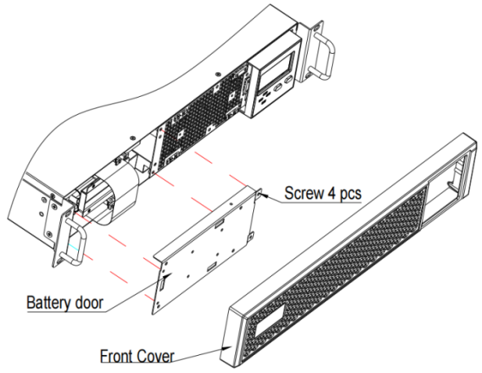
2/3 kVA
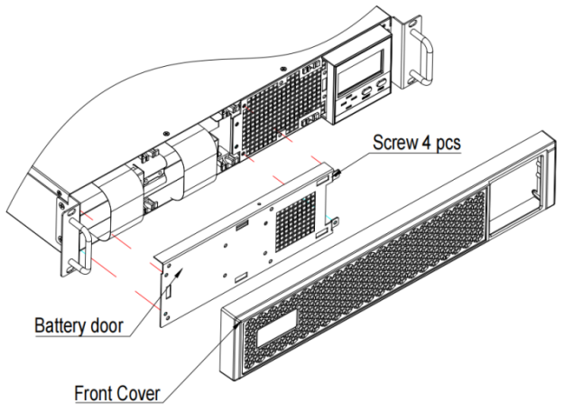
Fig.7-1 Removing the front plastic bezel cover and battery door
Step 3: Gently pull the battery wire out and disconnect battery wires.
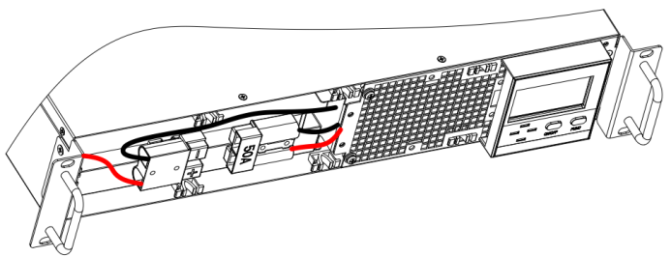
Step 4: Grasp the battery handle, and pull the internal battery pack out of the UPS, as shown in Fig.7-2.
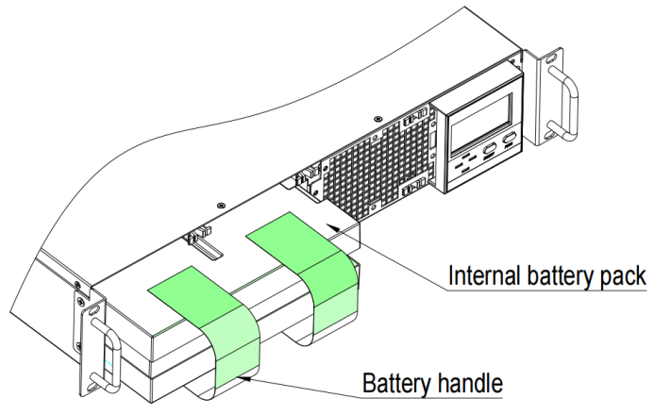
Fig.7-2 Pulling out the internal battery pack
Step 5: Unpack the new internal battery pack. Take care not to destroy the packing.
Compare the new and old internal battery pack to make sure they are the same. If so, proceed with Step 6; otherwise stop operation and contact your local dealer.
Step 6: Line up and slide in the new internal battery pack.
Step 7: Reconnect the battery plug and battery receptacle, and gently push the battery wire and internal battery pack back into the UPS.
Step 8: Reattach the front battery door with the three screws.
Step 9: Reattach the front plastic bezel cover to the UPS.
(For battery pack assembly, refer to Annex C)

Do not replace the internal battery pack while the UPS is operating in Battery Mode. This will result in a loss of output power and will drop the connected load. Moreover, it will jeopardize personnel safety！

9. Battery disposal and replacement procedures

9.1 Battery Disposal
- Before disposing of batteries, remove jewelry, watches and other metal objects.
- Use rubber gloves and boots, use tools with insulated handles.
- If it is necessary to replace any connection cables, please purchase the original materials from the authorized distributors or service centers, so as to avoid overheat or spark resulting in fire due to insufficient capacity.
- Do not dispose of batteries or battery packs in a fire. The batteries may explode.
- Do not open or mutilate batteries, released electrolyte is highly poisonous and harmful to the skin and eyes.
- Do not short the positive and negative of the battery electrode, otherwise, it may result in electric shock or fire.
- Make sure that there is no voltage before touching the batteries. The battery circuit is not isolated from the input potential circuit. There may be hazardous voltage between the battery terminals and the ground.
- Even though the input breaker is disconnected, the components inside the UPS are still connected with the batteries, and there are potential hazardous voltages. Therefore, before any maintenance and repairs work is carried out, switch off the breaker of the battery pack or disconnect the jumper wire of connecting between the batteries.
- Batteries contain hazardous voltage and current. Battery maintenance such as the battery replacement must be carried out by qualified personnel who are knowledgeable about batteries. No other persons should handle the batteries

9.2 Battery Replacement Procedures
- Turn off UPS completely.
- Remove covers from the UPS.
- Disconnect the battery wires one by one.
- Remove metal bars which are used to fasten batteries.
- Replace batteries one by one.
- Screw metal bars back to UPS.
- Connect the battery wires one by one. Take care of electrical shock while connecting the last wire.

10. Trouble shooting
This section describes checking the UPS’ status. This section also indicates various UPS symptoms a user may encounter and provides a troubleshooting guide in the event the UPS develops a problem. Use the following information to determine whether external factors caused the problem and how to remedy the situation.

10.1 Checking UPS status
It recommended that checking the UPS operation status every six months.
- Check whether the UPS is faulty: Is the Fault Indicator on? Is the UPS sounding an alarm?
- Check whether the UPS is operating in Bypass mode. Normally, the UPS operates in Normal Mode. If it is operating in Bypass Mode, stop and contact your local representative, or Channel Support.
- Check whether the battery is discharging. When the utility input is normal, the battery should not discharge. If the UPS is operating in Battery Mode, stop and contact your local representative, or Channel Support.

10.2 Solution
When the fault indicator is on, press FUNC button to see the fault code and warn code. Fault and warn codes are listed as following:

Code | Event | Possible cause | Solution
1 | Warn: Battery not connected | Battery not connected | Check if battery switch is off or battery cables are disconnected
2 | Warn: EPO | Emergency power off | Short the EPO terminal 1&2 to activate EPO
3 | Warn: Inverter on Less | Available ups capacity is less then the load capacity. | Please reduce the load capacity or make sure that the UPS capacity is big enough.
4 | Warn: Input voltage abnormal | Utility is failure | /
 |  | Input surge protector opens | If utility is normal but rectifier is not working, reset input surge protector
5 | Warn: Line neutral wires reversed | Input Line and neutral is reversed | Check the polarity of line wire and neutral wire
6 | Warn: Bypass voltage abnormal | Bypass voltage is out of bypass range or is off | Check if utility power is indeed out of range.
7 | Fault: Bypass fail | Bypass input power is abnormal or bypass input breaker is opened. | Please recover bypass input power, otherwise there will be no backup circuit when UPS is faulty.
8 | Warn: Bypass over load | Load is on bypass and is overload | Remove some loads to ensure that total loads is less than 95% of rated capacity
9 | Warn: Bypass overload timeout | Load is on bypass and overload. Overload time is longer than the overload capacity of bypass. UPS will shutdown output and loads will loss power. | Remove some loads and restart UPS again. When UPS is working normally, turn on loads one by one.
10 | Warn: Transfer times over limit in 1 hour | Transfer times between inverter and bypass is over 5 in recent 1 hour. UPS works in bypass mode. | Check if output is overload or some loads are shorted. Remove the failure loads and restart the UPS or wait for starting inverter automatically.
11 | Warn: output shorted | Something shorted | Please remove all loads from UPS output. Check if UPS output is shorted. If not, please check all loads.
12 | Warn: End of discharge | UPS works in battery mode for long time after utility failure. UPS output will be off until utility power is on. | Please save your data when UPS alarm “utility fail”
13 | Fault: Battery self-detect fault | UPS transfer to battery mode for 20 seconds to check if batteries are normal | Please check the battery cables connect.
14 | Fault: Rectifier fault | Bus over voltage, bus unbalance, rectifier starting failure, bus under voltage, input fuse is off | Please contact with distributer or service center.
15 | Fault: Inverter fault | Inverter over voltage, inverter under voltage, | Please contact with distributer or service center.
16 | Warn: Rectifier over temperature | Rectifier heatsink is over temperature or the temp sensor is not connected correctly. | - Check if fans are working normally  - Check if any thing block ventilation  - Check if the sensor is connected correctly  Check if the environmental temp is over the range of UPS
17 | Fault: Fan failure | One or more fans are failure, fan wires are loosen | Please contact with distributer or service center
18 | Warn: Inverter overload | Loads are on inverter and over the capacity of the UPS | Remove some loads to ensure that total loads is under the capacity of the UPS
19 | Warn: Inverter overload timeout | Load is over the capacity of the UPS and timeout, UPS will transfer to bypass mode if bypass is available | Remove some loads to under 95%, UPS will transfer to inverter automatically
20 | Warn: Inverter over temperature | Inverter heat sink is over temperature or the temp sensor is not connected correctly. | Check if fans are working normally  Check if any thin block ventilation  Check if the sensor is connected correctly  Check if the environmental temp is over the range of UPS
21 | Warn: Battery low | UPS works in battery and battery voltage is low | Recover input power or save data upon “battery low”
22 | Warn: input natural line lost | Input natural line disconnect | Please check the input cables connect.
23 | Fault: Bypass Fan failure | One or more fans are failure, fan wires are loosen | Please contact with distributer or service center.
24 | Warn: Manual shutdown | UPS will shutdown output or transfer to bypass mode | /
25 | Fault: Charger fault | There is no charger output. | Please contact with distributer or service center.
26 | Warn: EOD system inhibited | Prohibit turn on after system EOD | /
27 | Warn: input over current | Abnormal large current enter in rectifier. | Please contact with distributer or service center.
28 | Warn: auxiliary power supply lost | Auxiliary power supply abnormal. | Please contact with distributer or service center.
29 | Fault: UPS model fault | UPS model ID detect abnormal. | Please contact with distributer or service center.
30 | Fault: Output CT fault | Output current detection CT reversed connection | Please check the output current transformer connect.
31 | Fault: BMS Connect Fault | BMS communication failure | Please contact with distributer or service center.
/ | Battery discharge time diminishes | The battery has not been fully charged | Charge the battery for more than 10 hours.
 |  | UPS is overload | Check the loads and remove some devices.
 |  | Battery aged | Replace the batteries. Please contact with distributer or service center to obtain replacement components for batteries.

Please provide the following information when reporting fault UPS:
The UPS model and serial NO. the warn and fault code happened.
Details of fault, include LED indicates, buzzer beeps, power condition, load capacity and configuration of battery (long backup time model)

Annex A. Dry Contact Card
The dry contact card for option: phoenix port.
Max output current for them is 1A.
NC:normally close/NO:normally open
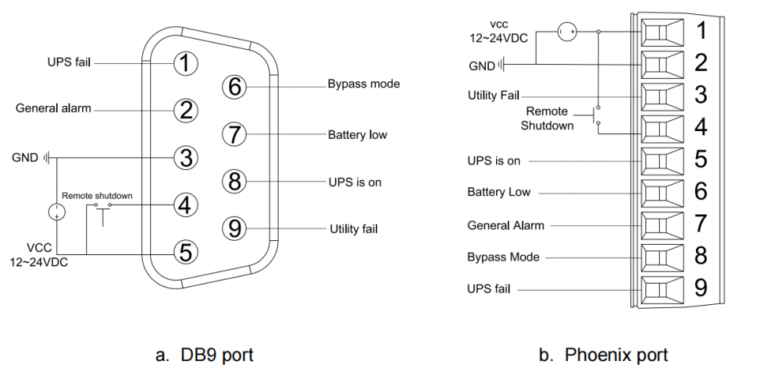
Description of Phoenix port:
Port PIN  Function | Phoenix | Description
VCC | 1 | External power supply.12VDC~24VDC, Common connection.
GND | 2 | External power supply GND
Utility fail(Other functions can be set) | 3 | Pin3 to pin1 is open if utility is failure. If not, NC.(Can set reverse logic)
Remote shutdown | 4 | 1.UPS shutdowns rectifier and inverter if utility is normal.  2.UPS shutdowns completely if in battery mode.  3.Remote shut down if in high level
Normal mode | 5 | Pin5 to pin1 is NC if UPS works in normal mode.(Can set reverse logic)
Battery low(Other functions can be set) | 6 | Pin6 to pin1 is open if battery voltage is low. If not, NC.(Can set reverse logic)
General alarm(Other functions can be set) | 7 | Pin7 to pin1 is open if something is abnormal. If not, NC.(Can set reverse logic)
Bypass mode | 8 | Pin8 to pin1 is close if UPS works in bypass mode. If not, NO.(Can set reverse logic)
UPS fail(Other functions can be set) | 9 | Pin9 to pin1 is open if something is failure in UPS. If not, NC.(Can set reverse logic)

Annex B. Battery Pack Assembly (rack tower model)
1k battery pack

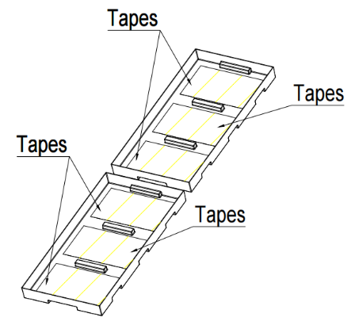
Step 1: Remove adhesive tapes.
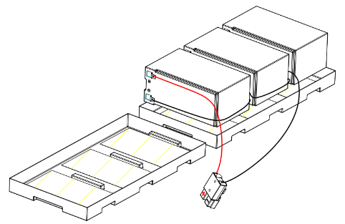
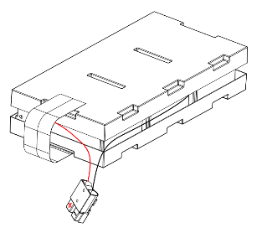
step 2: Connect all battery terminals as below.
Step 3: Put batteries on as below.

Step 4: Cover the other side of plastic shell as below. Finished.

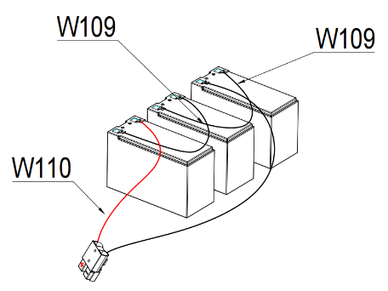
2k/3K battery pack
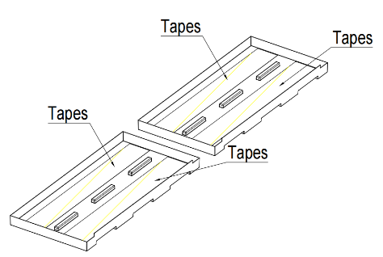
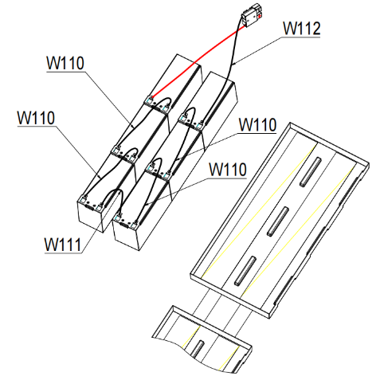
Step 1: Remove adhesive tapes.
Step 2: Connect all battery terminals as below.
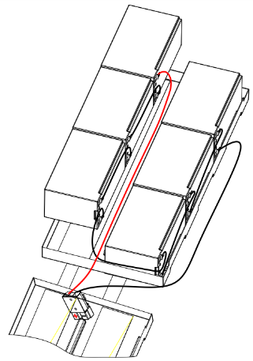
Step 3: Put batteries on one side of plastic shells.
Step 4: Cover the other side of plastic shell. Finished.
